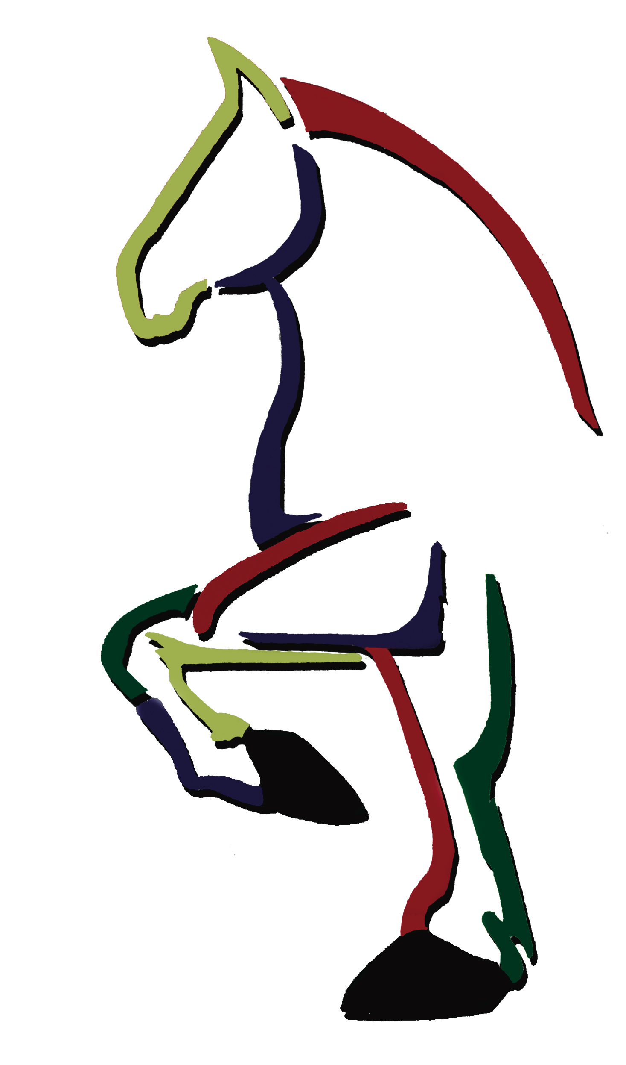® Belgian Draft Horse Alliance, Inc.
2019 Scholarship Application

The Belgian Draft Horse Alliance, Inc. is awarding a scholarship in 2019. Students currently enrolled in at least their sophomore year of college are encouraged to apply.

Name__________________________________________________________________________________________

Address_______________________________________________________________________________________

City________________________________________________________State_________Zip__________________

High School attended and GPA______________________________________________________________

Current College or University you are attending. Please include a current

transcript.)___________________________________________________________________________________

Past and present community services_____________________________________________________

________________________________________________________________________________________________

Please tell us about your involvement with the Belgian Draft Horse Corp. of America

________________________________________________________________________________________________

________________________________________________________________________________________________

Please tell us about your horse activities__________________________________________________

________________________________________________________________________________________________

Applicants are required to submit an essay consisting of 300-500 words on why you should be chosen to receive the Belgian Draft Horse Alliance, Inc. Scholarship as well as three letters of recommendation. Application, current transcript, essay, and letters must be postmarked by October 1, 2019. Recipients will be selected by the Belgian Draft Horse Alliance, Inc. Board and their decision is final. Scholarship funds will be paid directly to the recipient.

Belgian Draft Horse Alliance, Inc., PO Box 335, Wabash, IN 46992

