**HOW TO COMPLETE A REGISTRATION APPLICATION**

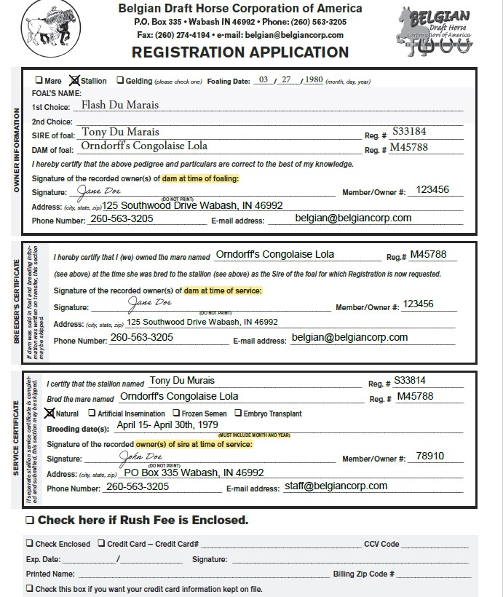

SIGNATURE OF THE OWNER OF THE DAM AT THE TIME SHE WAS BRED (DO NOT PRINT) IF BREEDING INFORMATION WAS FILLED OUT ON THE TRANSFER FOR THE MARE, DO NOT NEED TO FILL THIS SECTION OUT.

DO NOT FORGET TO CHECK BOX (SEE BYLAWS ON RULES FOR FROZEN SEMEN AND EMBRYO TRANSFERS)

DON’T FORGET TO CHECK A BOX FOR THE SEX OF THE HORSE

SIGNATURE OF THE OWNER OF THE DAM AT THE TIME THE HORSE WAS BORN (DO NOT PRINT)

DATE HORSE WAS BORN

DATE BREEDING OCCURRED (APPROX. 11 MONTHS BEFORE FOALING DATE ABOVE)

ANYONE WANTING PAPERWORK PROCESSED WITHIN 7 WORKING DAYS CHECK THIS BOX AND INCLUDE $20 WITH FEES.

SIGNATURE OF THE STALLION AT THE TIME OF BREEDING (DO NOT PRINT) STALLION SERVICE FORMS ARE AVAILABLE IN REPLACE OF THIS SECTION

**SEE BACK PAGE**

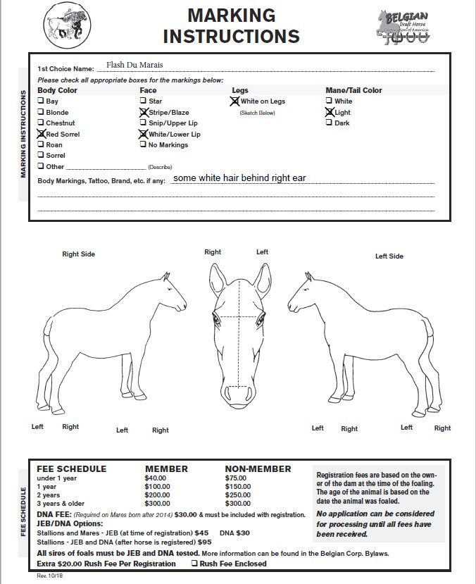

FEES ARE BASED ON OWNER OF THE DAM AT THE TIME OF FOALING.

BE SURE TO DRAW ALL MARKINGS, INCLUDING MARKINGS ON LEGS

BE SURE TO FILL OUT COMPLETELY

**MARES BORN AFTER 2014, ARE REQUIRED TO BE DNA TESTED WHICH IS AN EXTRA $30.00 FEE.**

**ANY STALLION WHO HAS REGISTERED OFFSPRING ARE REQUIRED TO BE DNA AND JEB TESTED. THIS IS AN EXTRA $75.00 FEE AT THE TIME OF REGISTRATION, OR AN EXTRA $95.00 FEE AT A LATER DATE.**