HOW TO COMPLETE A TRANSFER
SEND ORIGINAL CERTIFICATE OF REGISTRATION WITH TRANSFER
TRANSFER DATE IS THE DATE HORSE WAS PUCHASED BY BUYER
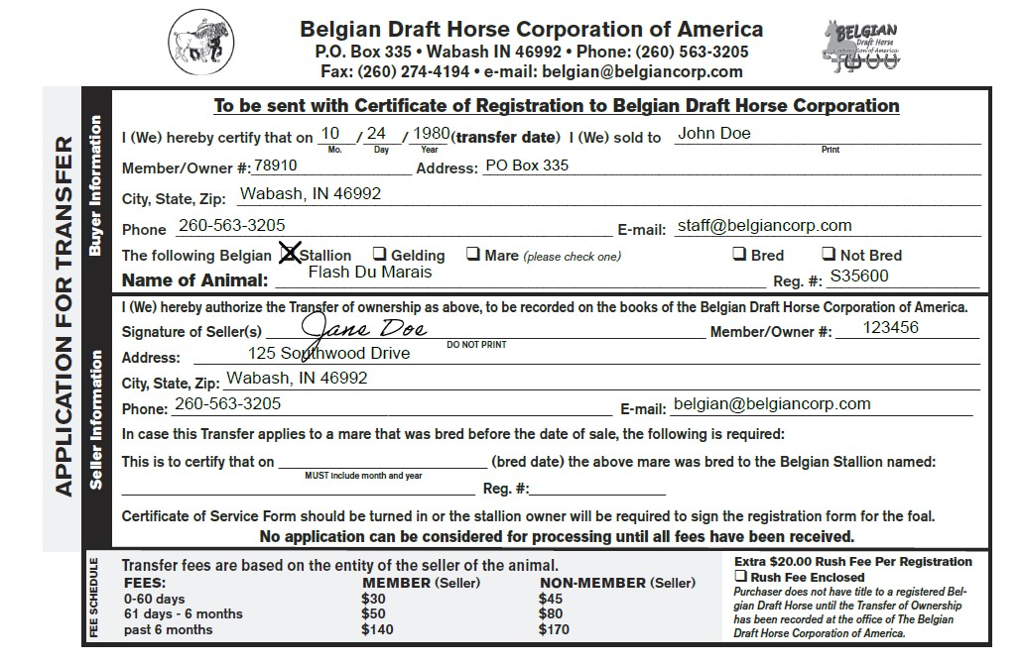
CHECK BOX IF TRANSFERRING A MARE
FEES ARE BASED ON THE MEMBERSHIP STATUS OF THE ACCOUNT THE HORSE IS CURRENTLY IN.
FILL OUT WITH AS MUCH INFO AS POSSIBLE, DO NOT WRITE NONE UNDER MEMBER #. WE ASSIGN NON-MEMBER #
FILL OUT THIS PORTION TO AVOID FILLING OUT BREEDER’S CERTIFICATE ON REGISTRATION OF OFFSPRING
IF NOT REGISTERED YET, DO NOT PUT PENDING IN THE REG # BOX AND INCLUDE THE FIRST NAME PICK FROM THE REGISTRATION APPLICATION
ANYONE WANTING PAPERWORK PROCESSED WITHIN 7 WORKING DAYS CHECK THIS BOX AND INCLUDE $20 WITH FEES.

