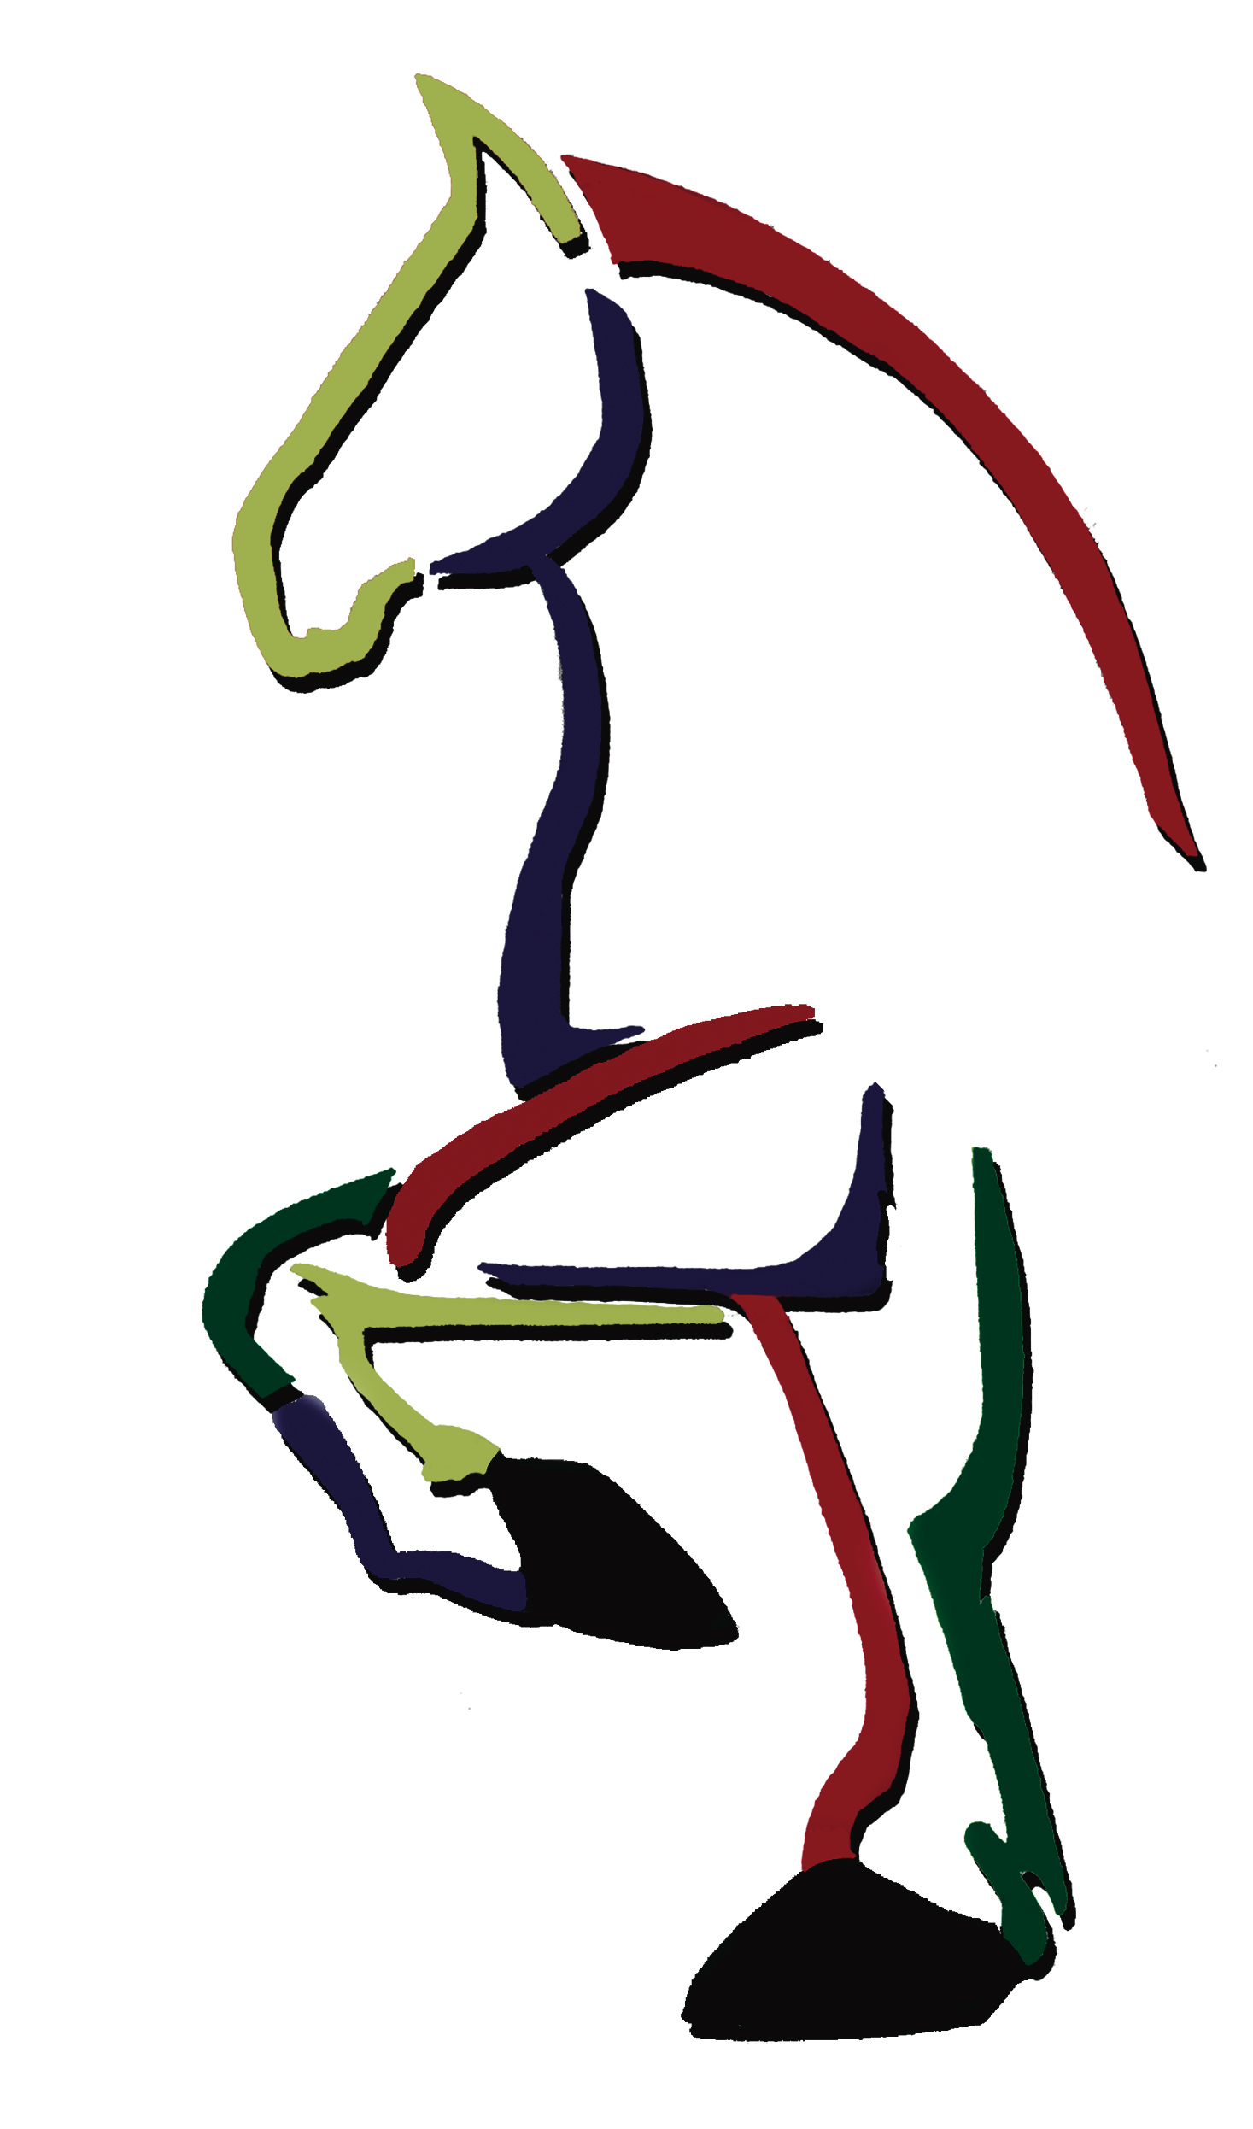® Belgian Draft Horse Youth Ambassador Program

The Belgian Draft Horse Alliance, Inc. has created a program to encourage the involvement of youth between the ages of 13-18. Participants will spend two days developing leadership skills, learning about the corporation, participating at the Belgian Draft Horse Expo, and touring local members’ farms. Participants will have the opportunity to help promote the Belgian horse through activities like horse shows, sales, and the Belgian Review. Participants who are selected will be reimbursed for their travel to the Belgian Draft Horse Expo and Annual Meeting of Members. Other events ambassadors choose to attend are optional and travel funds will not be reimbursed. To be considered for the program, please complete the application and return it by April 1, 2023. Selected participants will need to be available July 7-8th for training in Pennsylvania. There are limited number of spots available. Participants will be notified if they have been selected after the Belgian Alliance meeting on May 5th.

Name__________________________________________________________________________________________

Address_______________________________________________________________________________________

City________________________________________________________State_________Zip__________________

Email (if available): ______________________________ Phone: ___________________________

Age_____________

T-shirt Size: ___________________________

Please tell us about your involvement with the Belgian Horse (experience is not needed to apply):

________________________________________________________________________________________________

________________________________________________________________________________________________

Please list any clubs/groups, organizations, activities you have participated in:

______________________________________________________________________________________________
Please attach a paragraph on why you would like to participate in the Belgian Draft Horse Ambassador Program.

Return forms to: Michelle Keaffaber, Belgian Draft Horse Corporation
PO Box 335, Wabash, IN 46992 or Belgian@belgiancorp.com

